Kim Forrester

**Holistic Wellbeing Educator | Author | Speaker**

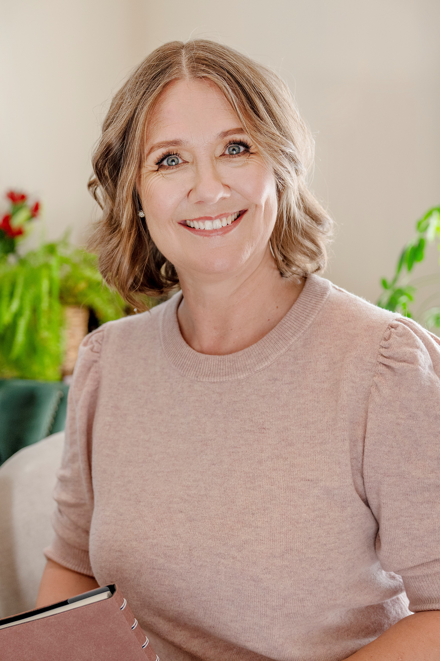**Kim Forrester is a mother, nature lover, global traveller, holistic wellbeing advocate and kindness enthusiast. As an award-winning author, educator, and consultant, she combines cutting edge science with spiritual philosophy to inspire holistic wellbeing and fullness of living.**

She has featured in media throughout Australia, New Zealand, Asia and the USA and regularly contributes to wellbeing and lifestyle publications all over the world. An experienced and engaging speaker, Kim is available to talk on a wide range of wellness and lifestyle topics. She is also the host of the Eudaemonia podcast, where she takes a deep dive into the habits and traits that can help us flourish in life.

Kim has formal qualifications in Philosophy and Positive Psychology, and her first book, Infinite Mind, was awarded a Silver Medal in the global 2016 Living Now Book Awards.

Born in Aotearoa New Zealand and currently residing in Dunedin, Kim spent more than two decades as a global citizen, living in several countries throughout Europe, South-east Asia, and the Pacific. [**www.kimforrester.net**](http://www.kimforrester.net)

### **Byline**

[Kim Forrester](https://kimforrester.net/) is an award-winning author, holistic wellbeing educator, and consultant. Kim blends science with spiritual philosophy to inspire fullness of living, and regularly contributes to wellbeing and lifestyle publications all over the world. Her award-winning book, Infinite Mind, is a collection of true psychic experiences and the modern research that is beginning to explain these phenomena.

### **Social Media**

### **Facebook:** Kim Forrester Holistic Wellbeing (@kimforresterwellbeing)

**Instagram**: @iamkimforrester_

### **Suggested Topics**

* Holistic wellbeing: the importance of wellbeing from the inside, out.
* Te Whare Tapa Whā and spiritual wellbeing in the 21st century.
* Four ways to choose happiness.
* Career or calling? How to set authentic goals.
* Authentic living: are you really being ‘you’?
* Ageing gratefully: healing our attitude toward ageing.
* Kindness: the ultimate superpower.
* 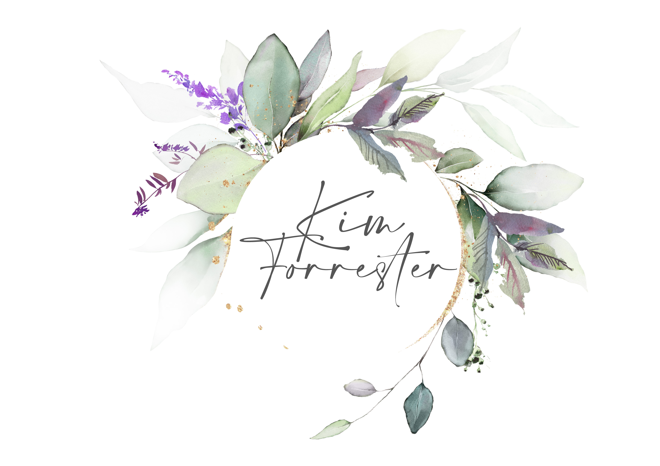Is success failing us? Dissecting the superficiality of modern 'success'.
* General wellbeing and modern spirituality topics.